6115 – MAHENDRA INSTITUTE OF ENGINEERING AND TECHNOLOGY

***********************************************************************************

AIR QUALITY MONITORING

TEAM : proj_223287_team_1

TEAM ID : 569

YEAR : |||

!!!!!!!!!!!!!!!!!!!!!!!!!!!!!!!!!!!!!!!!!!!!!!!!!!!!!!!!!!!!!!!!!!!!!!!!!!!!!!!!!!!!!!!!!!!!!!!!!!!!!!!!!!!!!!!!!!!!!!!!!!!!!!!!!!!!!!!!!!!!!!!!!!!!!!!!!!!!!!!!!!!!!

TEAM MEMBERS NAME

SIDDARTH.K

SHAM.P

SASI KUMAR.V

SARATHI.S

SENTHIL MURUGAN.R

SATHISH KUMAR.K

**||||||||||||||||||||||||||||||||||||||||||||||||||||||||||||||||||||||||||||||||||||||||||||||||||||||||||||||||||||||||||||||||||||||||||||||||||||||||||||||||||||||||||||||||||||||||||||||||||||||||||||||||||||**

**MENTOR NAME :**

**SANTHANARAJ.M**

AIR ATMOSPHERE:

An atmosphere contains the air that we breathe and is a blanket of gases that surrounds Earth.

It is held near the surface of the planet by Earth's gravitational attraction.

A barometer is used to measure air pressure.

Argon, oxygen and nitrogen from the three main constitutions of the atmosphere.

Air is the most important component for the survival of life on Earth.

We breathe in air. The oxygen present in air is required for respiration of living beings.

The carbon dioxide present in air is essential for the green plants to manufacture their own food by the process of photosynthesis.

Air is the invisible mixture of gases that surrounds Earth.



AIR ENVIRONMENT :

Air is mostly gas  
  
Air is all around us, but we can't see it. So what is air, exactly? It's a mixture of different gases. The air in Earth's atmosphere is made up of approximately 78 percent nitrogen and 21 percent oxygen. Air also has small amounts of other gases, too, such as carbon dioxide, neon, and hydrogen.

As Earth cooled, an atmosphere formed mainly from gases spewed from volcanoes. It included hydrogen sulfide, methane, and ten to 200 times as much carbon dioxide as today's atmosphere.

After about half a billion years, Earth's surface cooled and solidified enough for water to collect on it.

Air is the invisible mixture of gases that surrounds Earth. Air contains important substances, such as oxygen and nitrogen, that most species need to survive. Human beings (Homo sapiens), of course, are one of those species.

Sometimes, the word "atmosphere" is used instead of the word "air."

AIR POLLUTION:

Air pollution is contamination of the indoor or outdoor environment by any chemical, physical or biological agent that modifies the natural characteristics of the atmosphere.

Household combustion devices, motor vehicles, industrial facilities and forest fires are common sources of air pollution.

Vehicle emissions, fuel oils and natural gas to heat homes, by-products of manufacturing and power generation, particularly coal-fueled power plants, and fumes from chemical production are the primary sources of human-made air pollution.

Pollutants of major public health concern include particulate matter, carbon monoxide, ozone, nitrogen dioxide and sulfur dioxide.

* mobile sources – such as cars, buses, planes, trucks, and trains.
* stationary sources – such as power plants, oil refineries, industrial facilities, and factories.

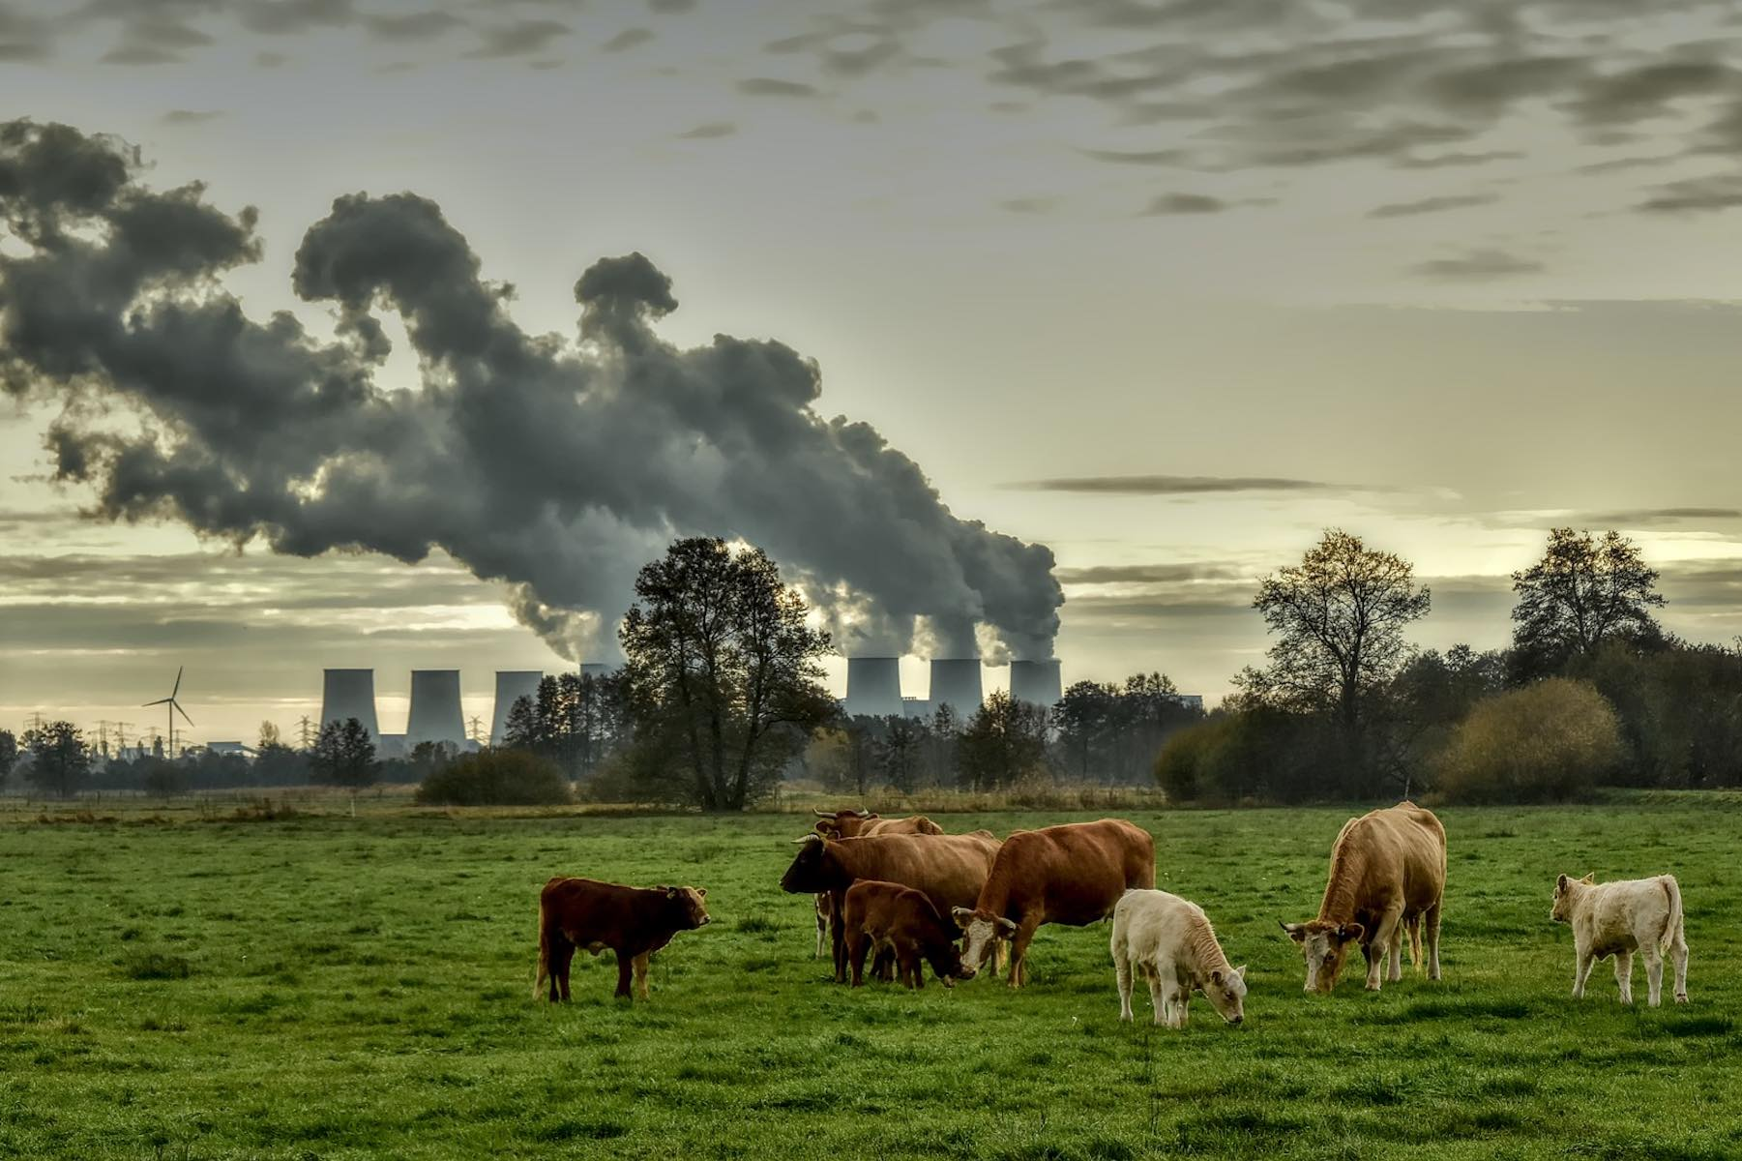

IOT (Internet of Things) :

The term IOT, or Internet of Things, refers to the collective network of connected devices and the technology that facilitates communication between devices and the cloud, as well as between the devices themselves.

One of the most common Internet of Things examples is smart watches. Wearable IOT technology like Fit bits and Apple Watches connect to other devices (like your smart phone) to share data.

They typically also connect to the internet to track GPS locations.

IOT applications span numerous verticals, including automotive, telecom and energy. In the consumer segment, for example, smart homes that are equipped with smart thermostats, smart appliances and connected heating, lighting and electronic devices can be controlled remotely via computers and smart phones.

By prototyping and testing your IoT solution, you can validate your design and architecture, and identify the risks and challenges.

The evolution of IoT extended beyond consumer devices to industry-specific applications. Sectors such as healthcare, manufacturing, transportation, and agriculture embraced IoT technologies to optimize operations, increase efficiency, and improve safety.

* Develop a Strategy.
* Ideate and Prototype.
* Connect, Adapt and Integrate Systems.
* Analyze Data.
* Operate.

**The Five Phases of Successful IoT Implementation**

Internet of Things (IOT) analytics is a data analysis tool that assesses the wide range of data collected from IOT devices.

IOT analytics assesses vast quantities of data and produces useful information from it.

AIR QUALITY ADVANTAGES :

Air quality monitoring is an important tool for improving air quality, protecting public health, and ensuring compliance with regulations.

It can also be used to identify pollution sources, monitor climate change, or support research and development.

In conclusion, an IoT-based air pollution monitoring system is a revolutionary solution that can provide accurate and real-time data about the air quality in a particular area.

It can help identify the sources of pollution and take necessary measures to reduce it, protecting the environment and human health.

Air sampling and monitoring helps protect air quality, human health and the environment.

Air pollution from transportation, power generation, industry and domestic sources can cause a variety of health problems, including cancer and respiratory and cardiac diseases.

provides a better understanding of the key pressures on the environment, the condition or state of the environment, leading to better responses and results.



IOT USE:

An IOT-based air and sound pollution monitoring system is implemented using a network of sensors, connectivity technologies, and data analytics platforms.

IOT Based Air Pollution Monitoring System monitors the Air quality over a web server using Internet and will trigger an alarm when the air quality goes down beyond a certain threshold level, means when there are sufficient amount of harmful gases present in the air like CO2, smoke, alcohol, benzene, NH3, LPG and NOx.

 Air quality sensors are deployed in strategic locations to measure pollutant levels such as particulate matter, gases, and volatile organic compounds (VOCs).

An IOT-based air and sound pollution monitoring system is implemented using a network of sensors, connectivity technologies, and data analytics platforms.

The sensors can track the air quality around us by measuring Particulate Matter, Carbon monoxide, Ammonia, Temperature, and Humidity.

 A microcontroller processes the data from the properly calibrated sensors and sends them to real time cloud storage through a Wi-Fi module.

Air quality sensors can help identify areas with high levels of pollution, allowing authorities to take action to reduce pollution levels.

This technology can also help individuals protect their health by alerting them to areas with high levels of pollution, allowing them to avoid exposure.

System uses air sensors to sense presence of harmful gases/compounds in the air and constantly transmit this data to microcontroller.

Also system keeps measuring sound level and reports it to the online server over IOT. The sensors interact with microcontroller which processes this data and transmits it over internet.

The proposed method in this research has been applied through use of IoT technology.

This method uses the fundamental characteristics of the IoT to gather daily readings of environmental pollution and to detect any particular sources of air pollution in a specific monitoring station.

Carbon emissions get released into the atmosphere from cars, airplanes, power plants and factories. They also get released by burning fossil fuels to create energy.

IoT in environmental technology allows us to collect real-time data on various environmental parameters, such as air quality, water quality, and soil moisture, among others, leading to actionable insights.



THANKING YOU